Name: Quang Huynh

Unit 4 Video Guide – Heimler’s History

Transoceanic Interconnections (1450-1750)

1. **Which area of the world led the development and expansion of maritime empires?** Europe led the development and expansion of maritime empires. The advancement of maritime technology would help with Europe leading.

2. **Explain how technological advancements made overseas exploration possible.**

|  |  |
| --- | --- |
| New Ships:  Fluyt  Caravel  Carrick  All of these ships were only used for trading, and thus they were cheaper and faster. | Navigation Instruments:  Lateen sail  Improved astronomical charts  Astrolabes  Magnetic compass |

3. **Why were Europeans searching for sea routes to Asia?**

Due to Muslims controlling most of the land-based trade routes, it was very difficult for Europeans to establish trade on their own terms on land. Therefore, Europeans were trying to find a new faster way to travel to Asia for the purpose of trading.

**What was accidentally “discovered” in the process?**

In the process of finding trade routes to Asia, the New World was accidentally discovered. Otherwise known as the Americas.

4. **Define Columbian Exchange.**

A biological exchange of animals, people, food, and diseases between the Eastern and Western hemispheres.

5. **How did Columbian Exchange lead to massive global change?**

The Columbian Exchange led to a massive global change by resulting in the exchange of new items and would greatly influence the lives of people. Moreover, the exchange of disease had a major impact on the population.

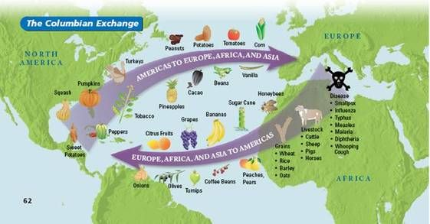

6. Explain the differences between types of labor in the early modern period.

|  |  |
| --- | --- |
| Chattel slavery | The slaves that were bought were personal property of the owners. |
| Encomienda system | In exchange of protection, natives would have to work on Spanish territory. |
| Hacienda system | The Spanish landowners would turn their little land grants to into huge plantations. Basically, an estate. |
| Mit‘a system | The Inca Mit’a system gathered people to do public works. But the Spanish Mit’a system coerced men to do labor for the sakes of private gain. |
| Indentured Servitude | A contract where one would work for a certain amount of time in exchange to go to the Americas. |

**ECONOMIC and POLITICAL changes resulting from transoceanic connections**

7. **What is mercantilism?**

Mercantilism is an economic system in which countries want to increase power and wealth by obtaining gold and silver and by making an approved balance of trade.

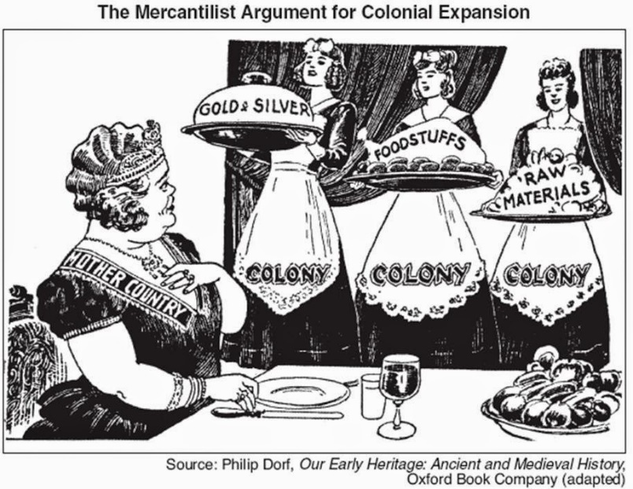

8. **Which European power set up a trading-post empire along the African coast?**

The Portuguese were the ones to set up a trading-post empire along the African coast.

9. **Why did European powers engage in empire building?**

Europeans powers engaged in empire building to increase power and wealth. It was due to mercantilism that the Europeans engaged in building empires.

**SOCIAL changes resulting from transoceanic connections**

10. What is the name of the social hierarchy shown in the diagram below?

The name of the social hierarchy shown below is called the Casta System.

**What is it based on?**

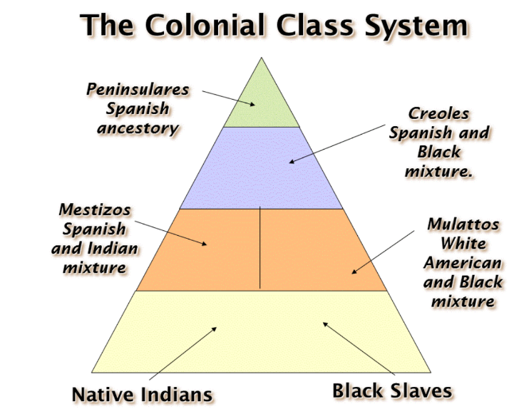The Casta System is based on ancestry and race.